**Transducer Theory**

**MMI501**

**Designing and Building a Loudspeaker**

**Diego Ugaz, Kerline Moncy,**

**Nate Paternoster**

**University of Miami**

**5/6/15**

**Table of Contents**

Overview 3

Equipment 4

Measurements 4

Experimental Designs 5

Design Data 7

Design Process 8

# Overview

This project entails all stages of designing and building a speaker. After choosing a driver the next step is to simulate the speaker’s design using the WinISD program. Our chosen enclosure was a rectangular shaped bass reflex design with one vent. We experimented with different enclosure and vent dimensions and settled on a design of one vent with a tuning frequency of roughly ~46Hz and an enclosure with a volume of 0.897 ft3.

The next step after simulation is to begin building. After gathering all of our materials, we measured and cut out the panels from a 2x4 fiberboard. Then the panels were attached together with screws and sealed with caulk. Two holes were drilled out for the input cap and the driver. The input cap was attached to the back panel and the driver to the front panel. Our chosen vent was cut from PVC pipe and attached above the driver.

After further listening tests we decided to add a tweeter and make our circuit into a crossover design. The crossover circuit we decided on was a 2nd order Butterworth with a crossover frequency of 300Hz. The components were soldered and the hole was cut on the front panel.

# Equipment / Materials

|  |  |
| --- | --- |
| **Name** | **Part Number** |
| Full-Range 4-1/2” 8-ohm driver | GRS 4FR-8 |
| 3/4” Medium-density fiberboard (MDF) 2x4 |  |
| 1-3/4”-long, 1/4”-diameter wood screws |  |
| GE 10.1-oz Black silicone window and door caulk |  |
| 1” PVC pipe |  |
|  |  |
|  |  |

# Measurements

|  |  |  |  |
| --- | --- | --- | --- |
| **Part** | **Length** | **Width** | **Thickness** |
| Front + Back Panels | 17.99” | 11.57” | 0.75” |
| Top + Bottom Panels | 5.94” | 11.57” | 0.75” |
| Left + Right Panels | 5.94” | 16.49” | 0.75” |
| Vent |  |  |  |
|  |  |  |  |

# Experimental Designs

After our enclosure shape and dimensions were decided on we experimented with dimensions of vent(s) to achieve frequency responses with the (1) lowest -3dB cutoff frequency, (2) highest –3dB cutoff frequency, (3) lowest overall Q, and (4) lowest resonant frequency.

1. Lowest -3dB cutoff frequency

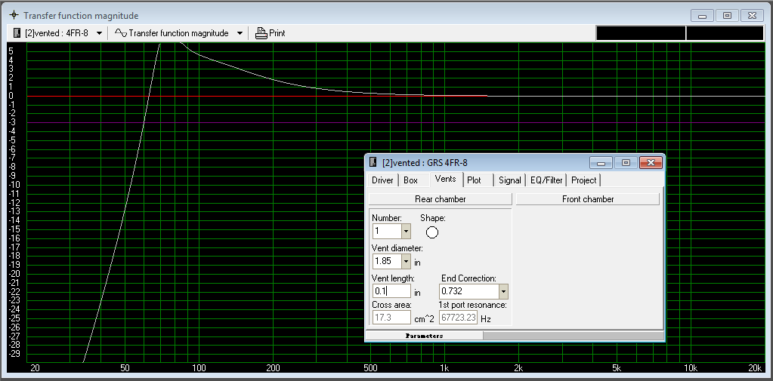 $f_{low}=60Hz$

1. 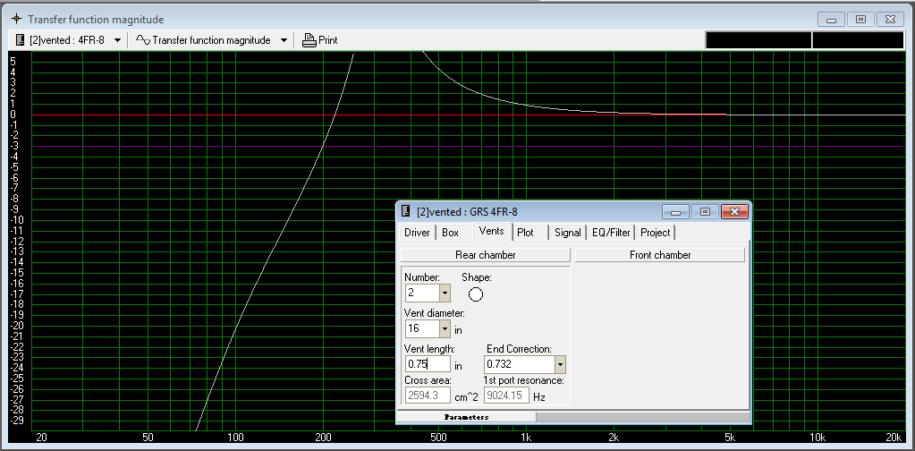Highest -3dB cutoff frequency

$f_{hi}=200Hz$

1. Lowest overall Q

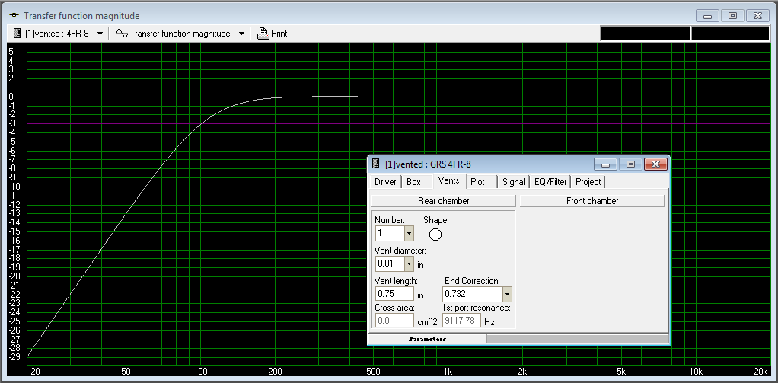 $Q≅1.0$

1. Lowest resonant frequency

 $f_{0}≅75Hz$

# Final Design Data

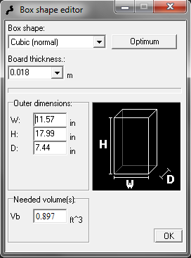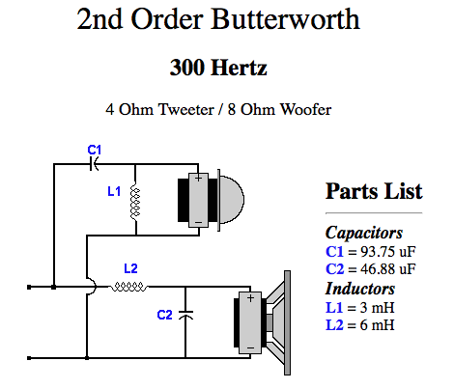

Crossover Circuit

Frequency Response

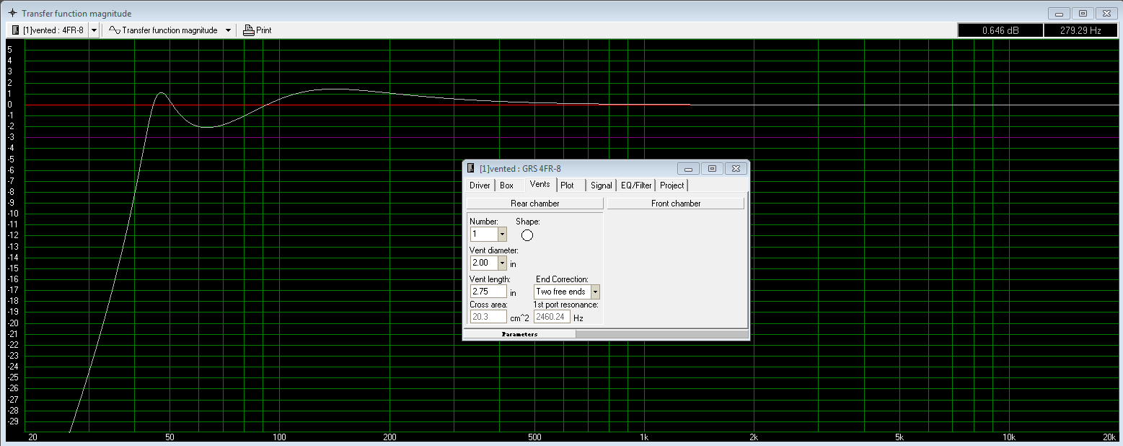

Enclosure Dimensions

**Design Process**

1. 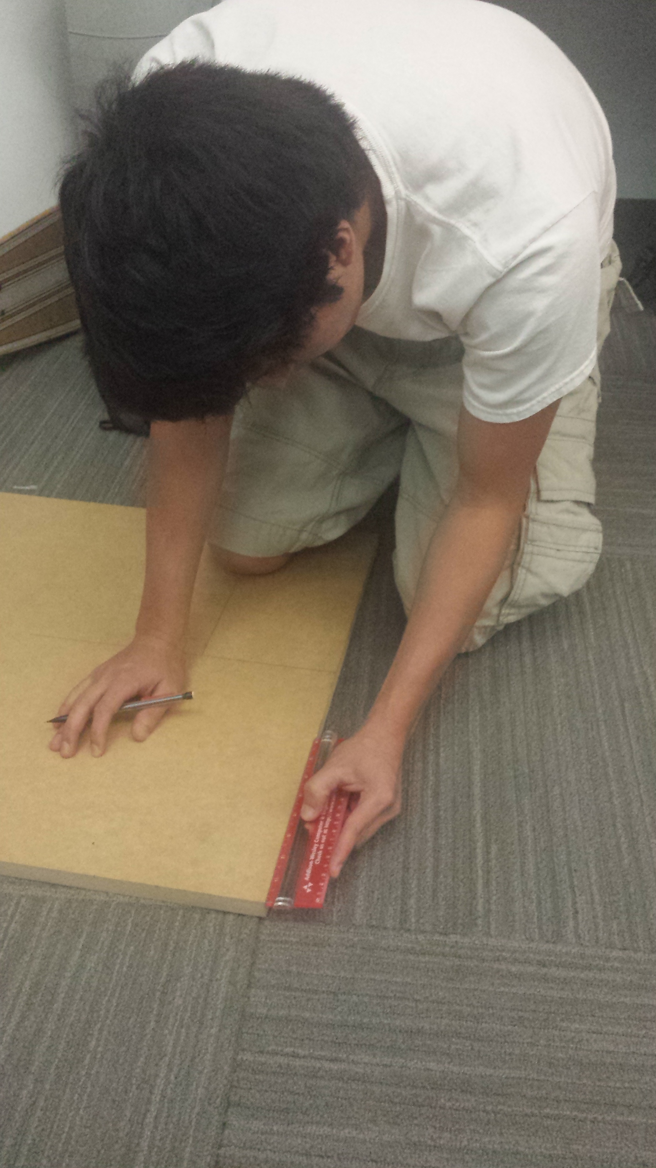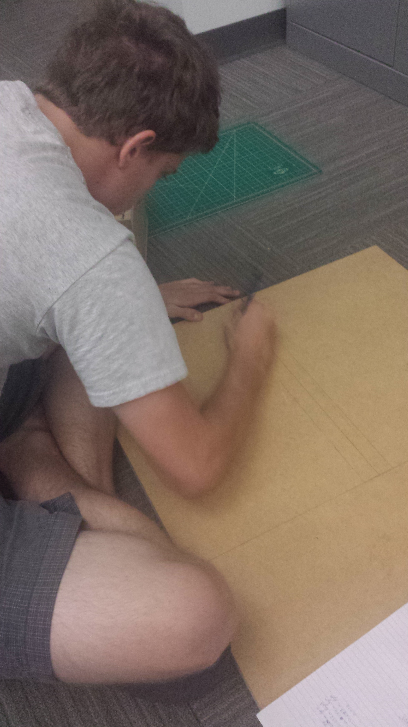Measuring the panels
2. Cutting the panels

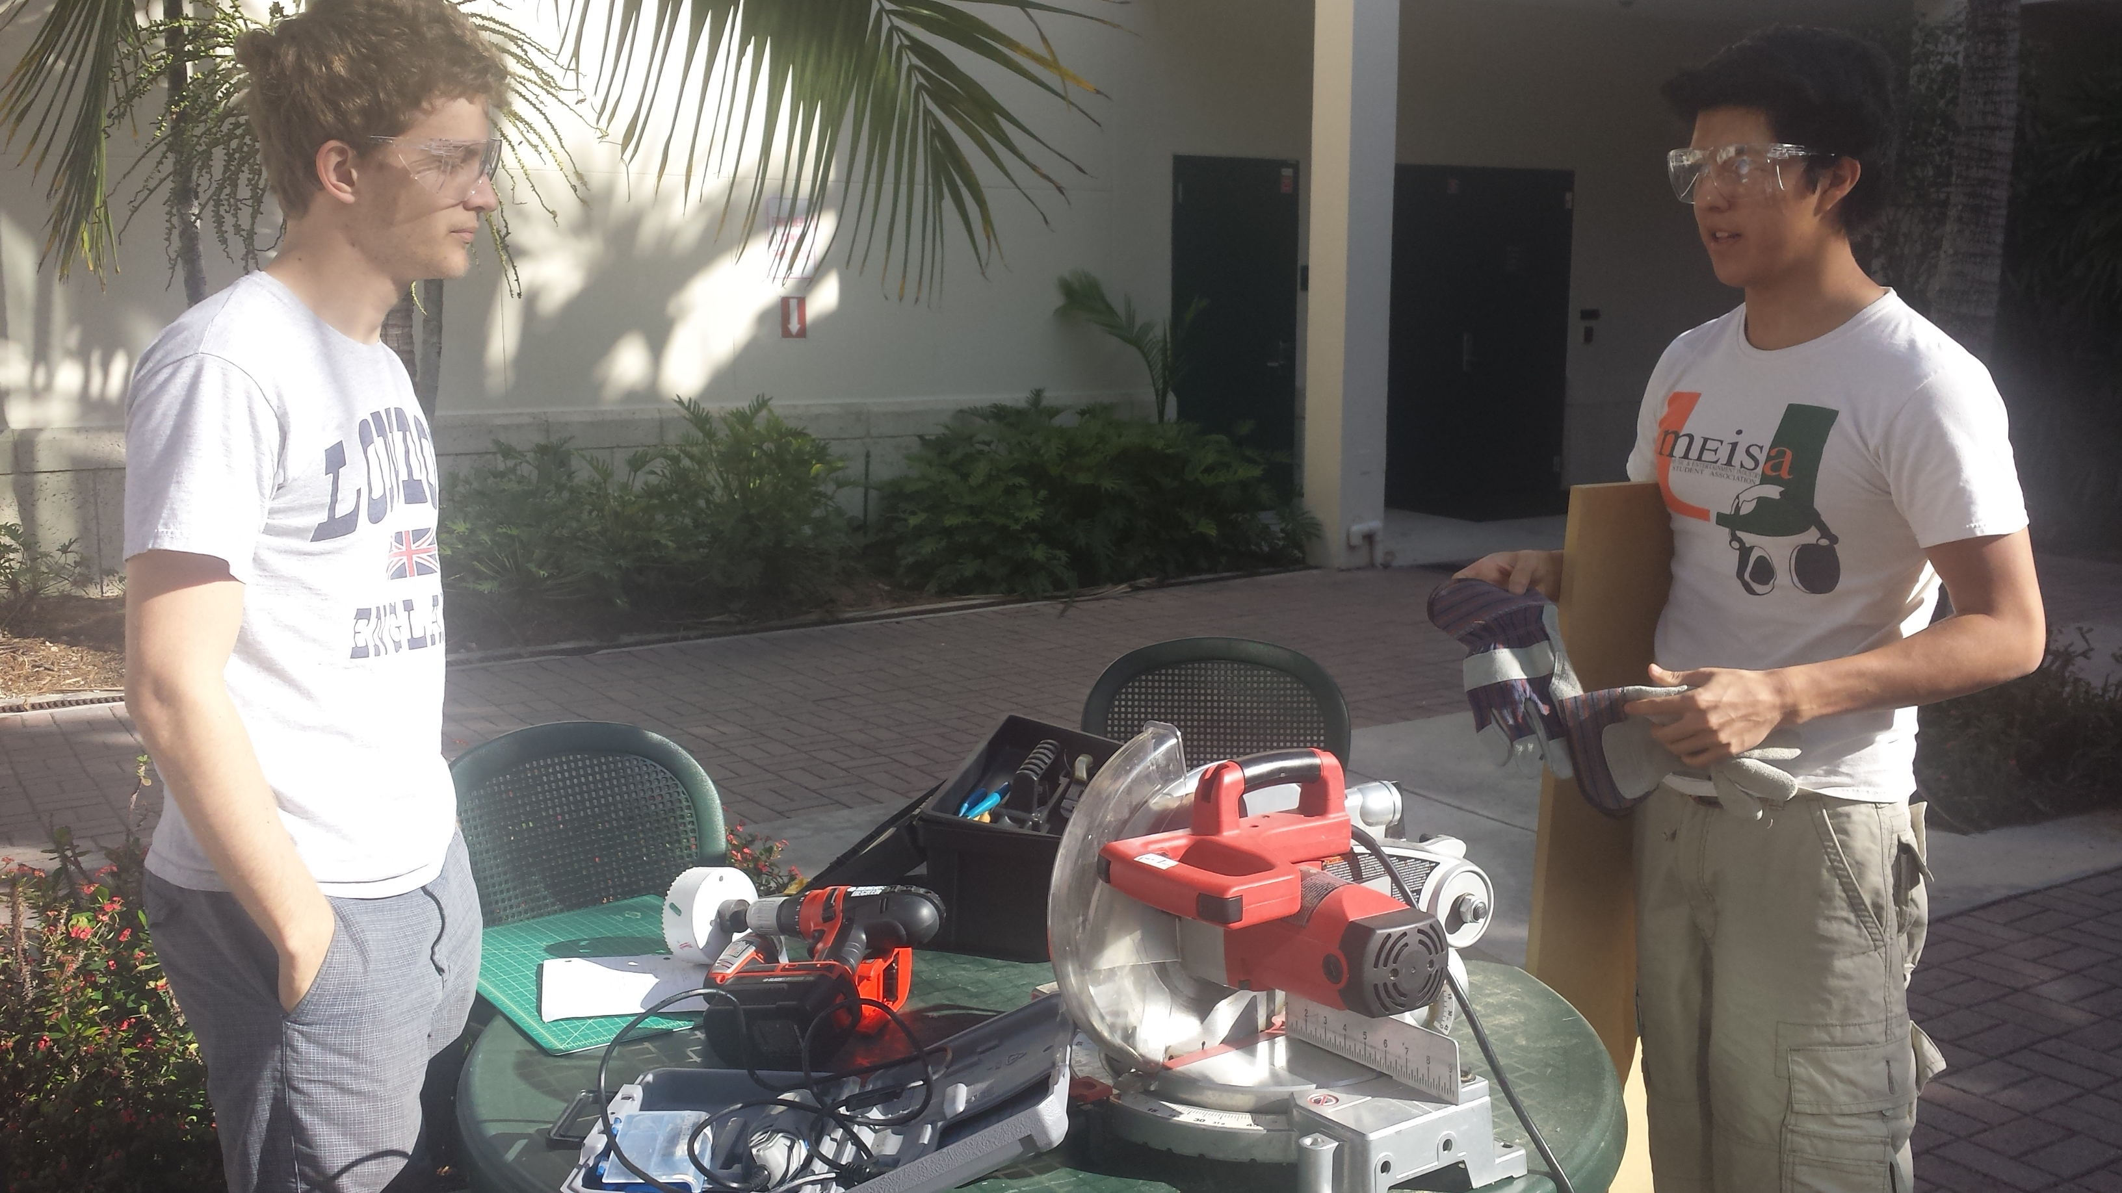

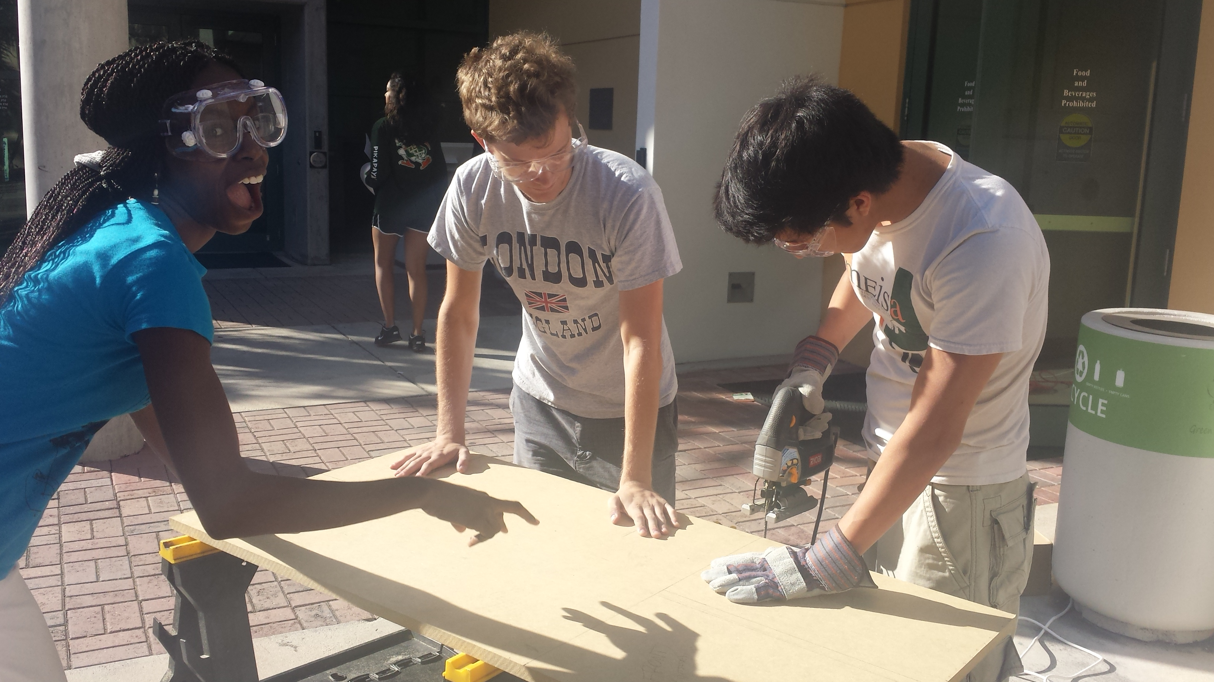

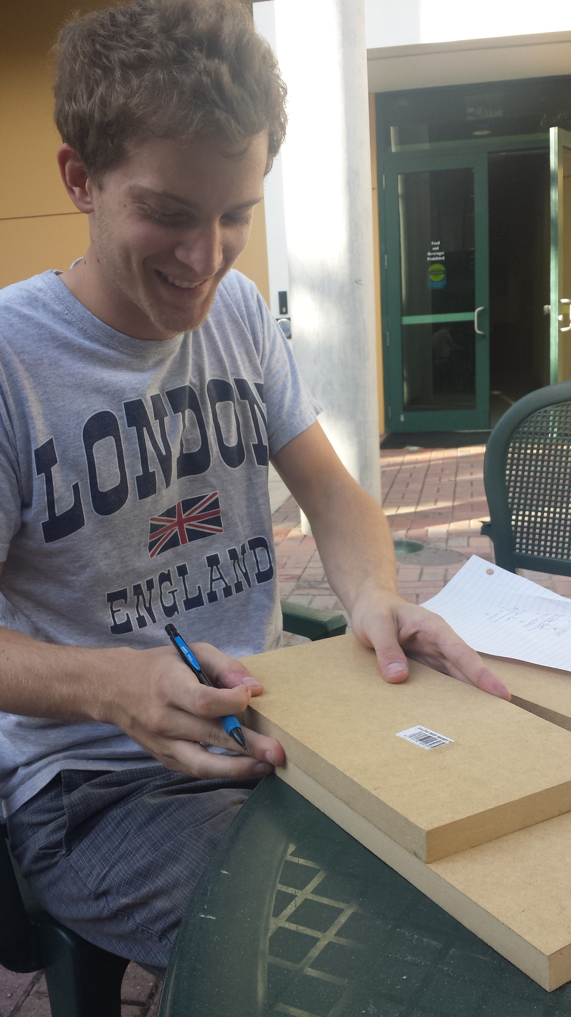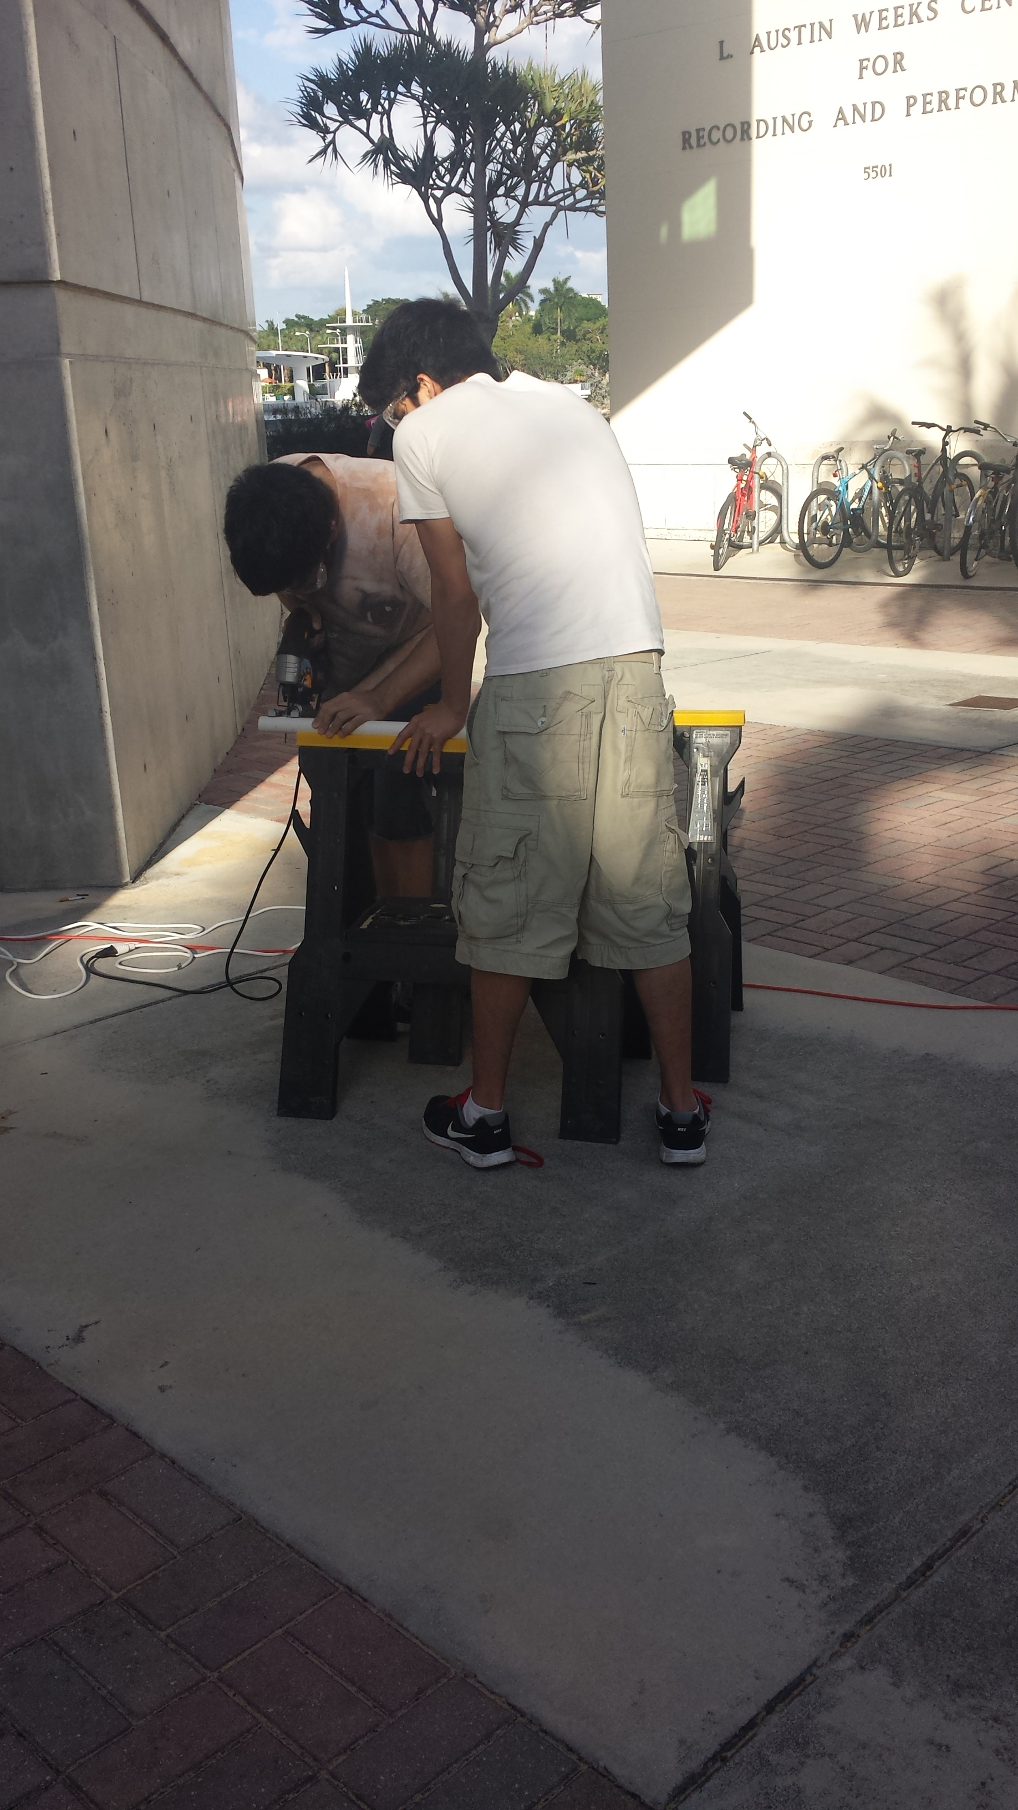

1. 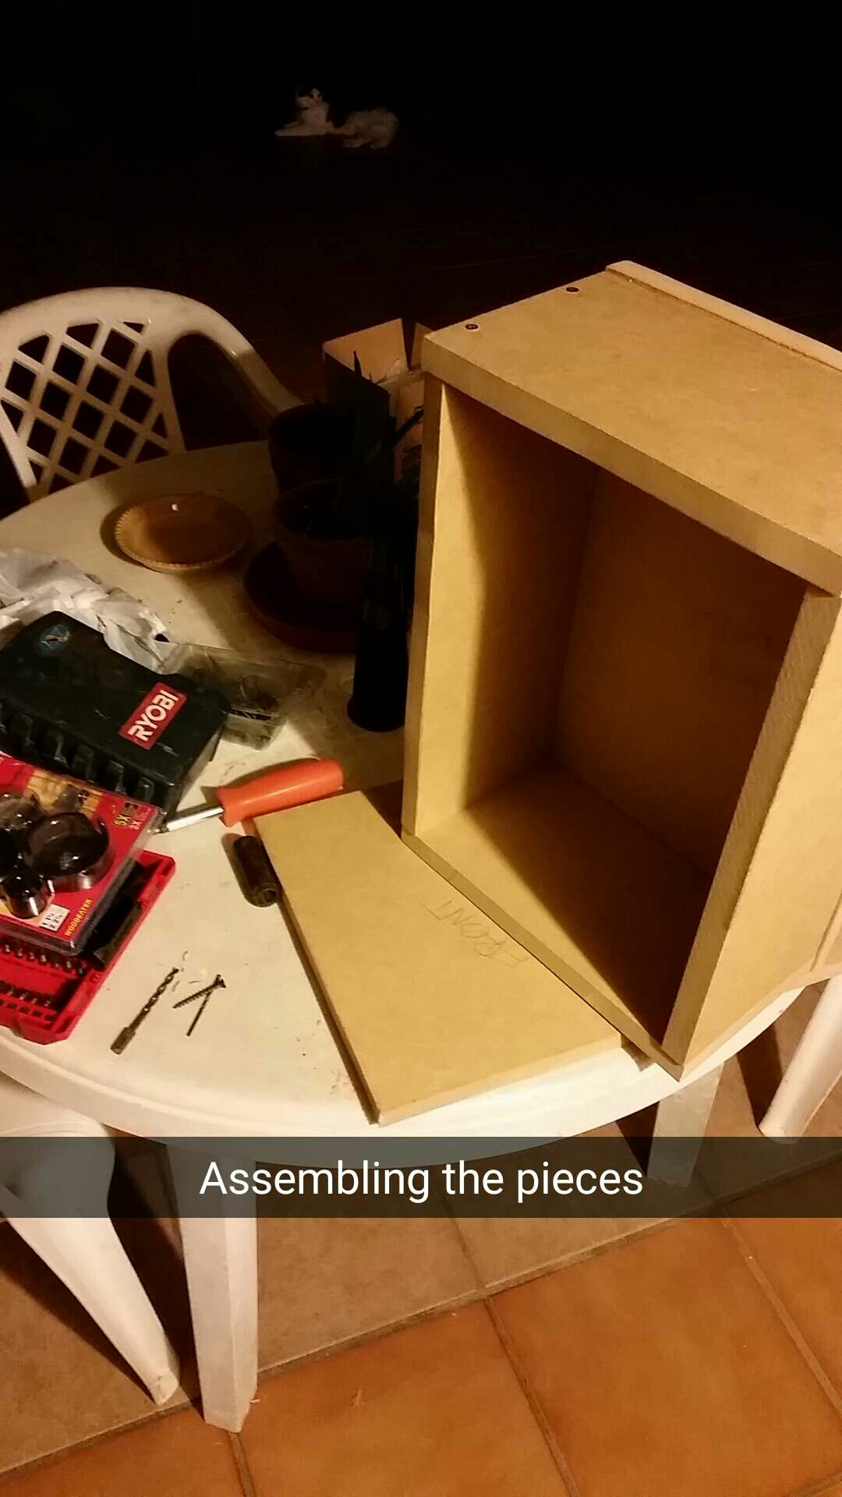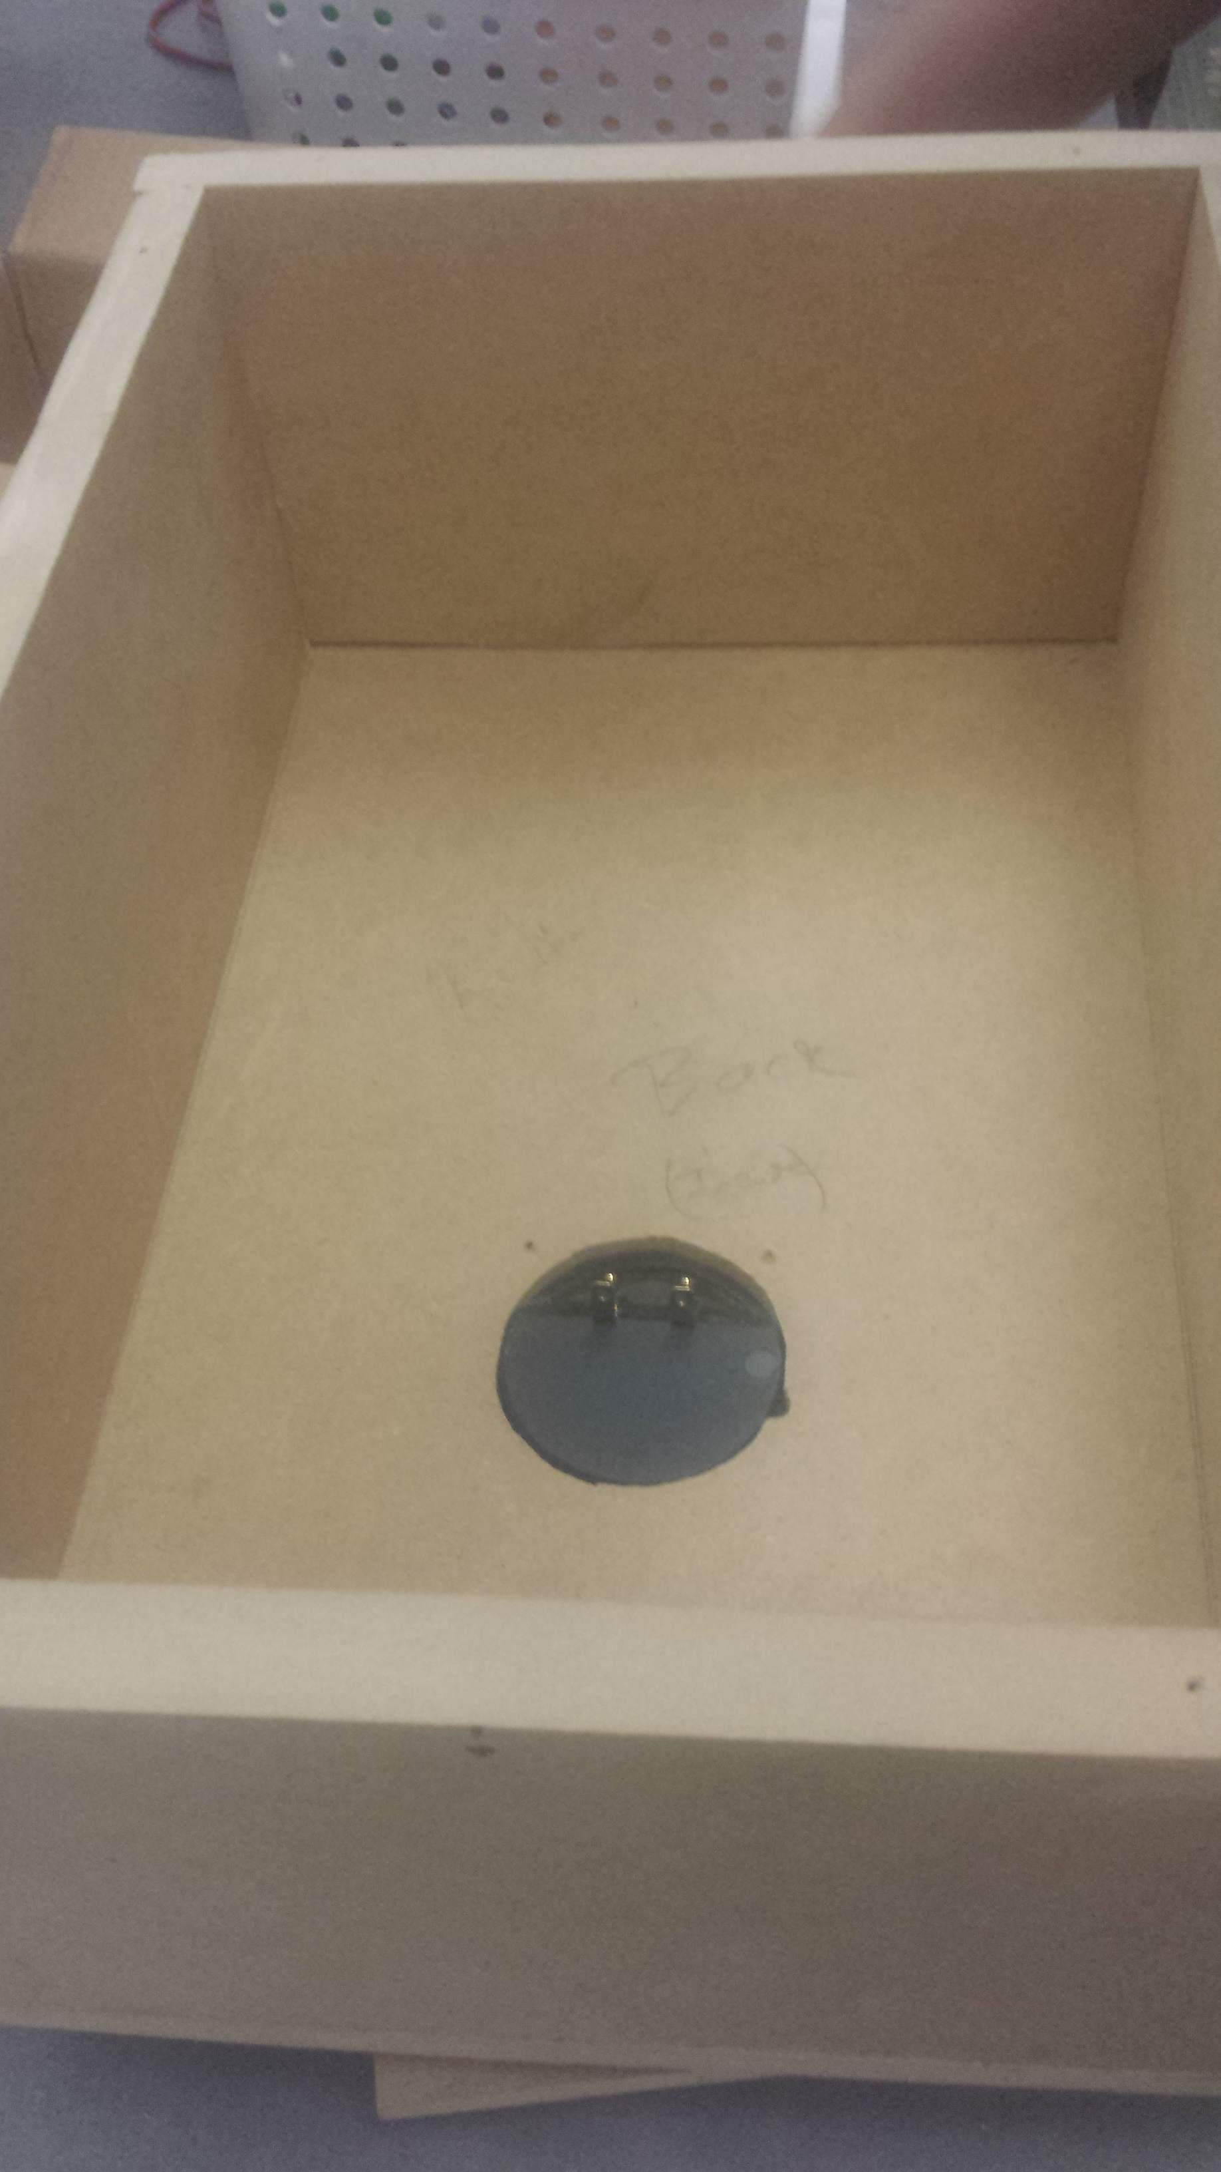Assembling the panels and attaching the input cup to the back panel
2. 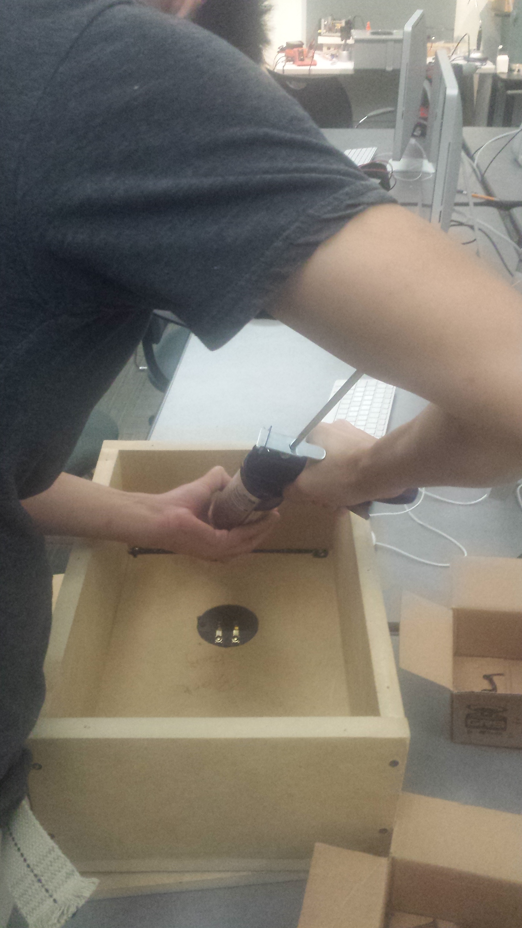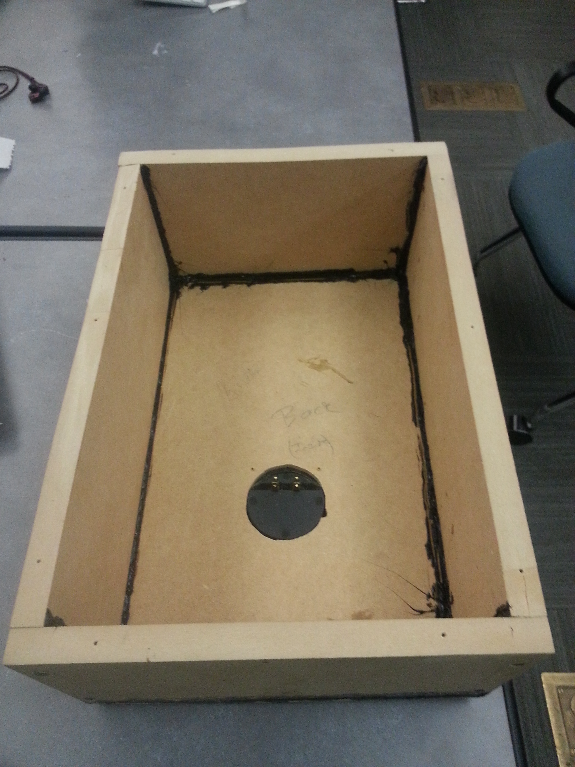Sealing the edges
3. 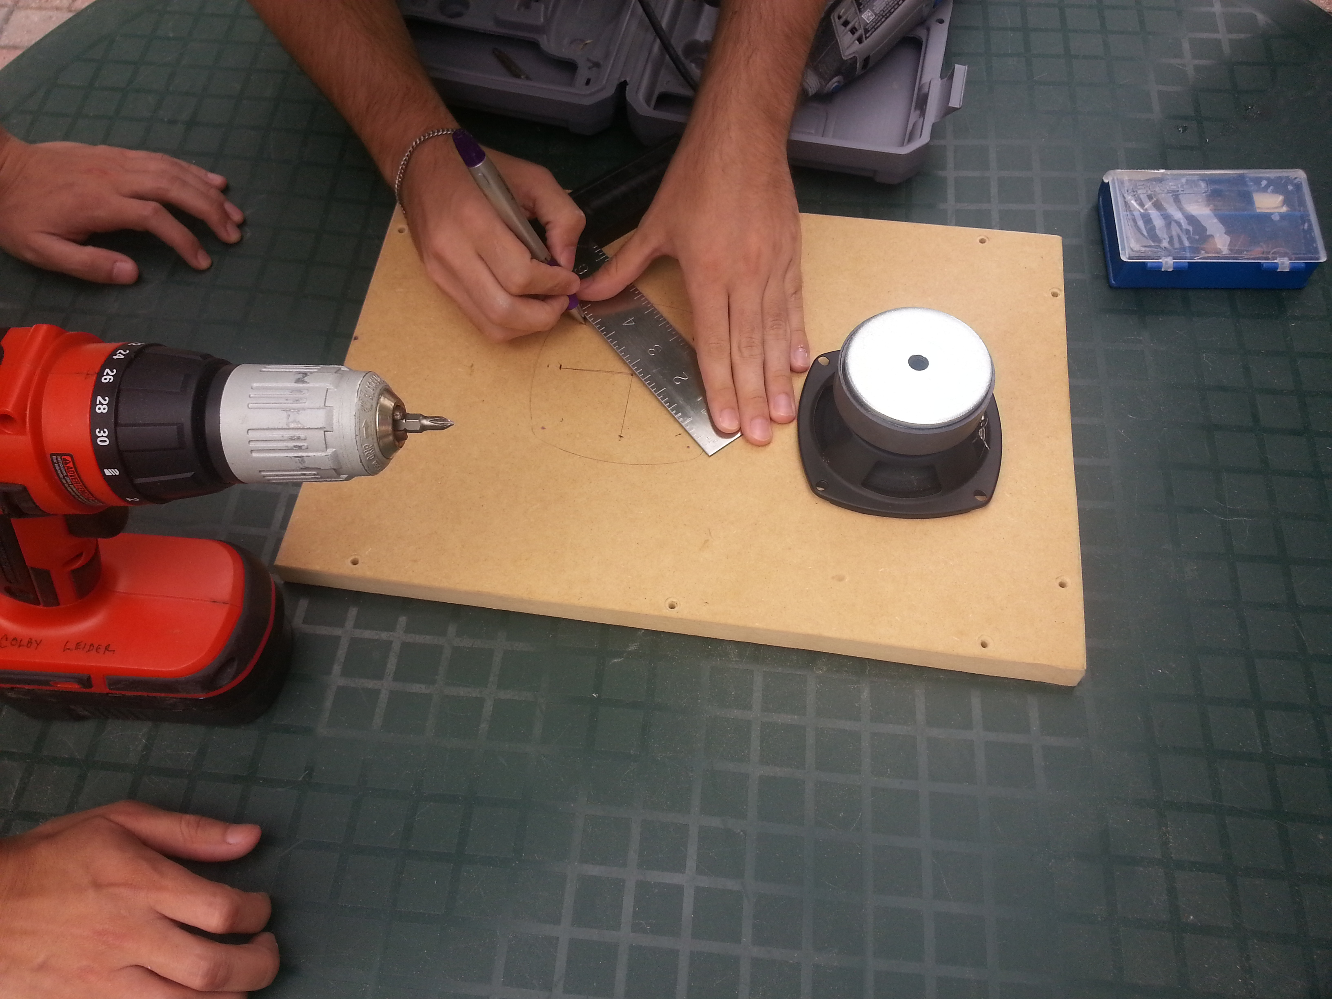Attaching the driver to the front panel

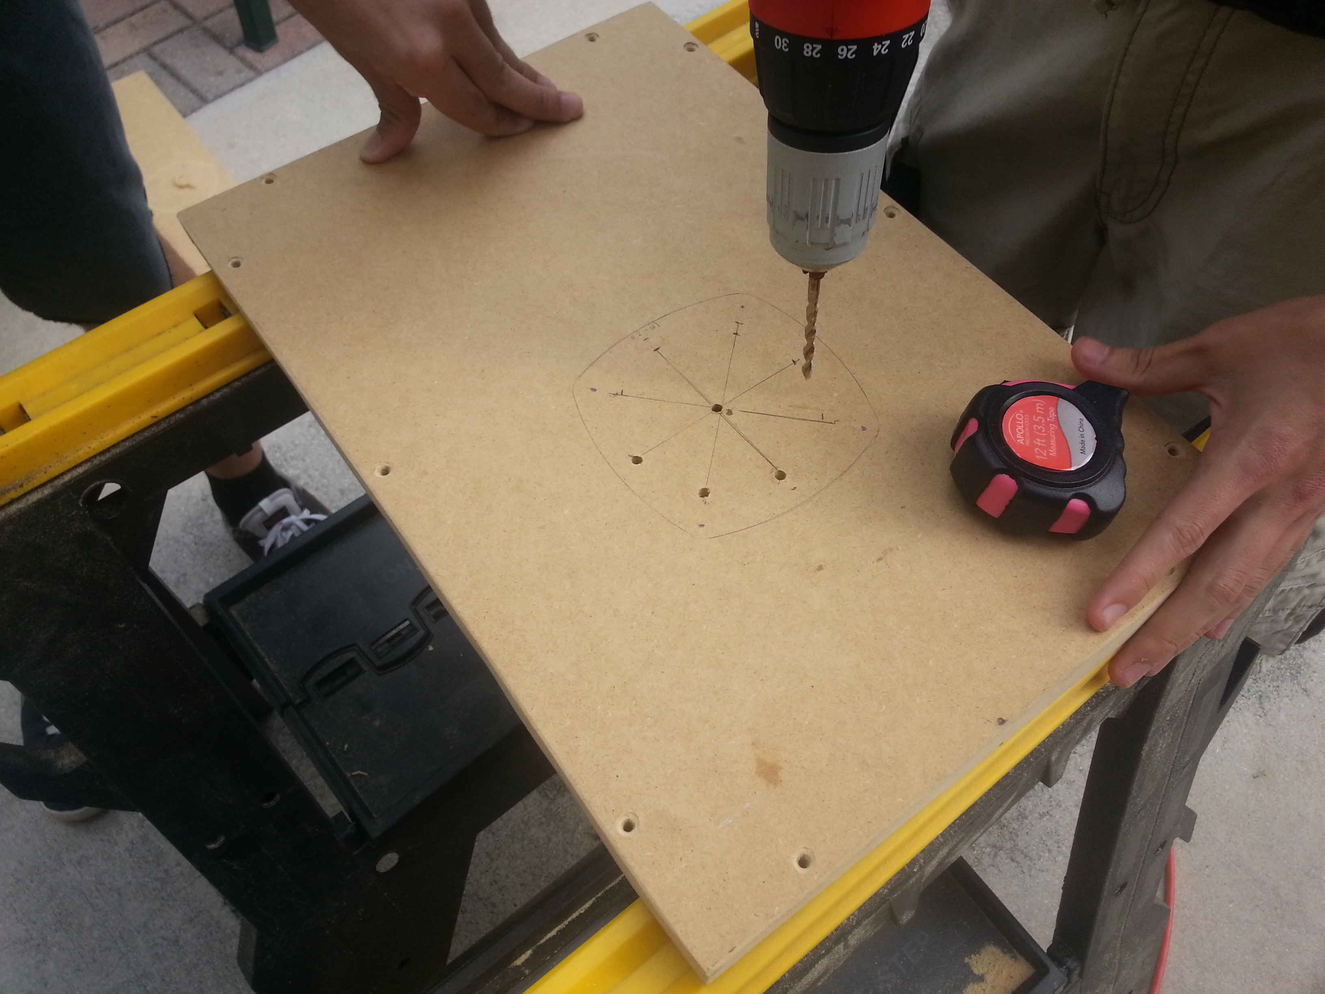

# Macintosh HD:Users:nthn888:Downloads:2015-05-04 18.23.54.jpgMacintosh HD:Users:nthn888:Downloads:2015-05-04 18.35.23.jpg

# Macintosh HD:Users:nthn888:Dropbox:Camera Uploads:2015-05-05 15.13.16.jpgAttaching the driver and vent to the front panel

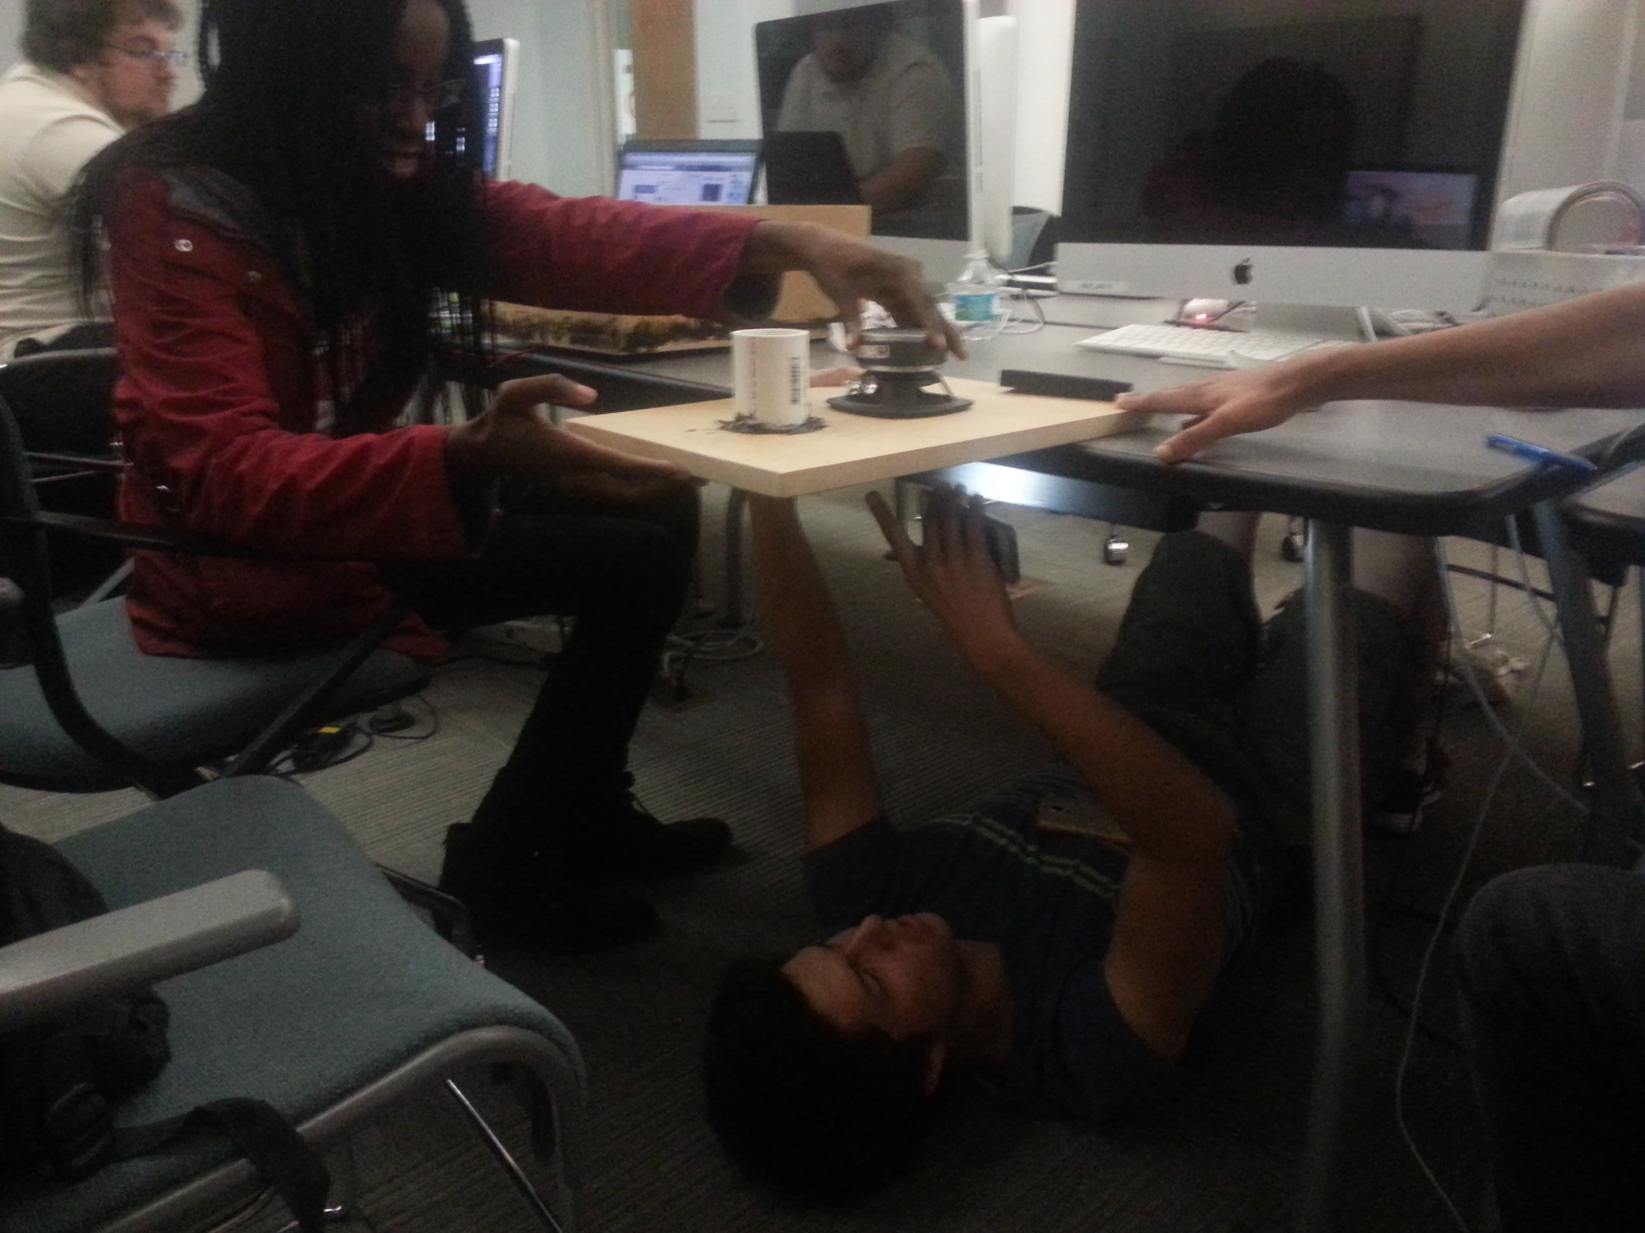

1. 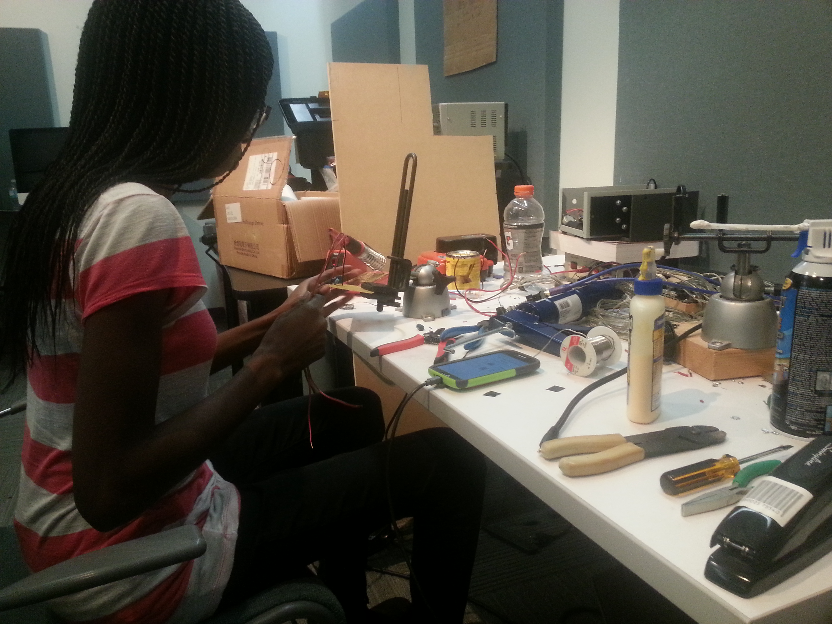Soldering the crossover circuit

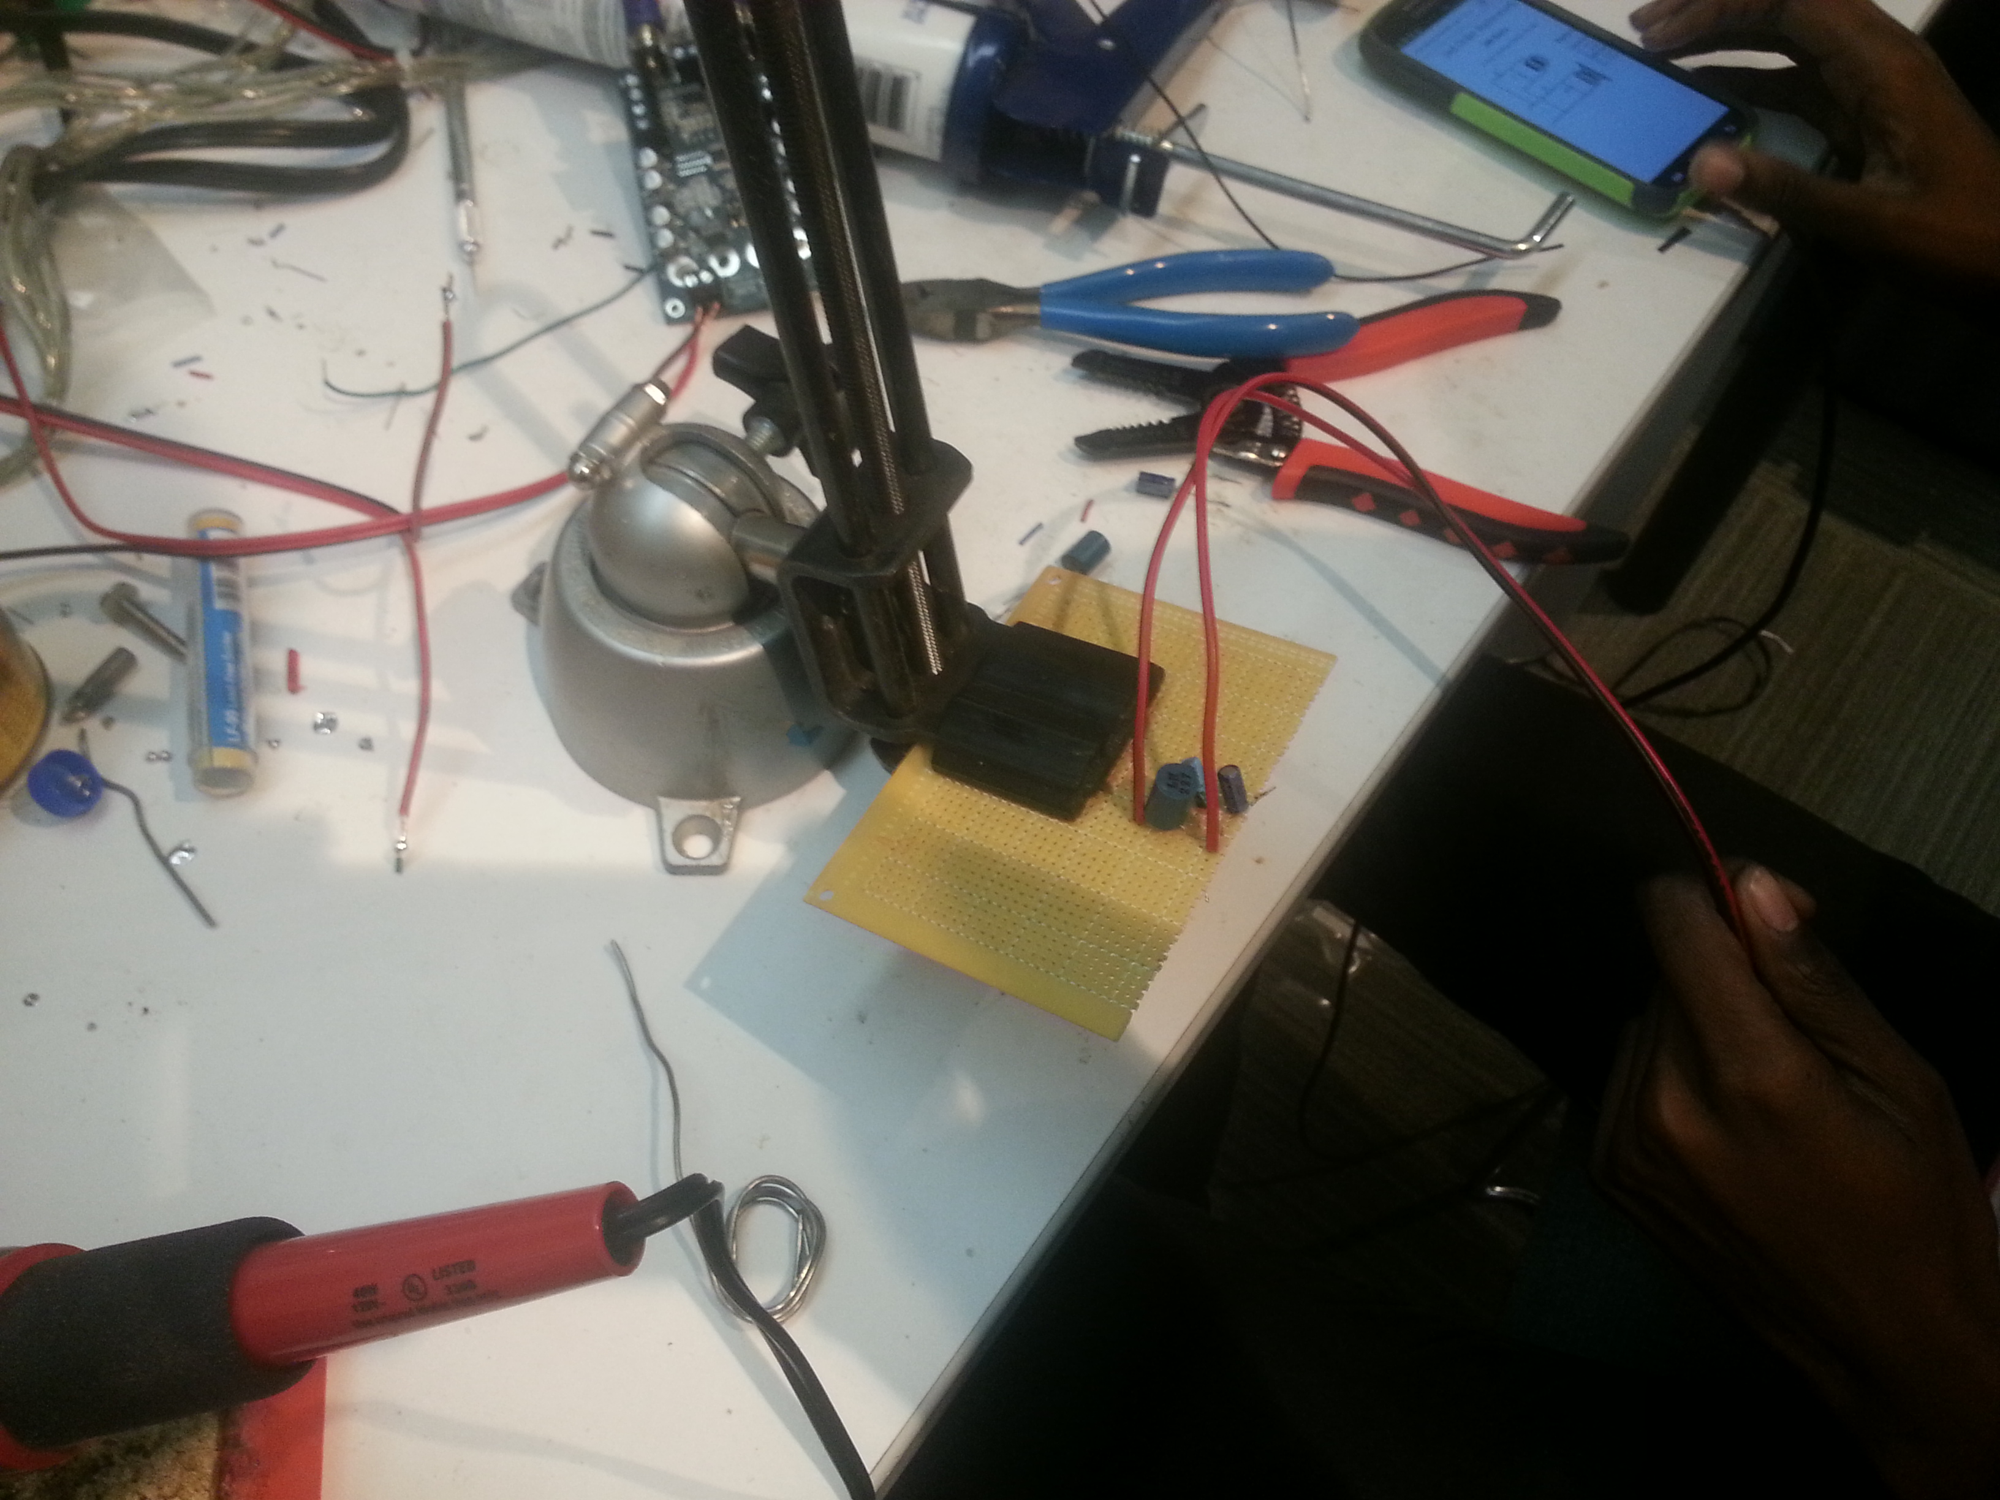

1. 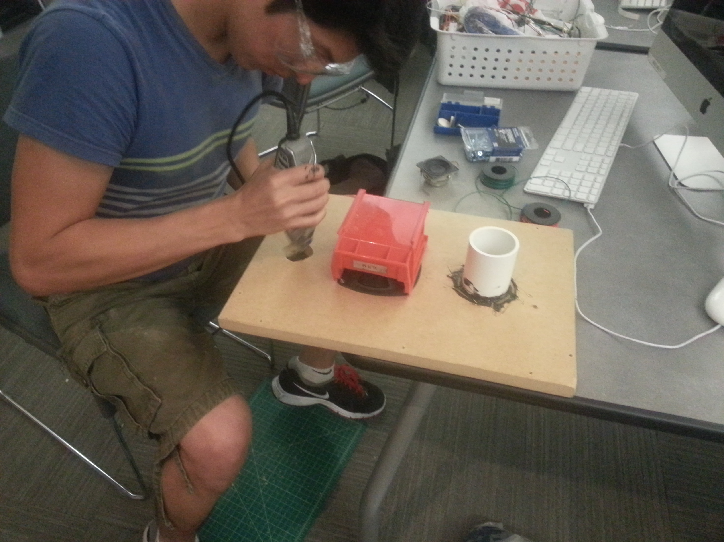Attaching the tweeter to the front panel

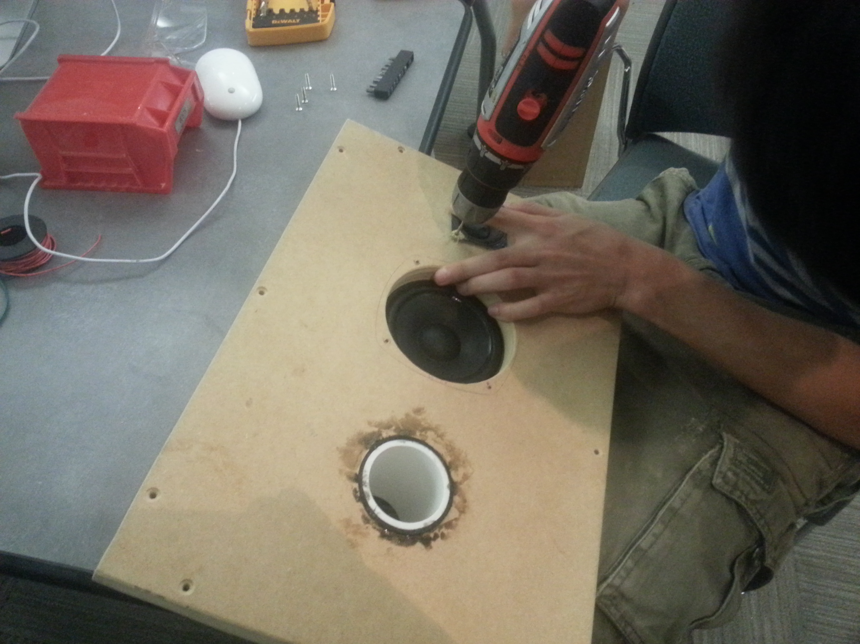

1. 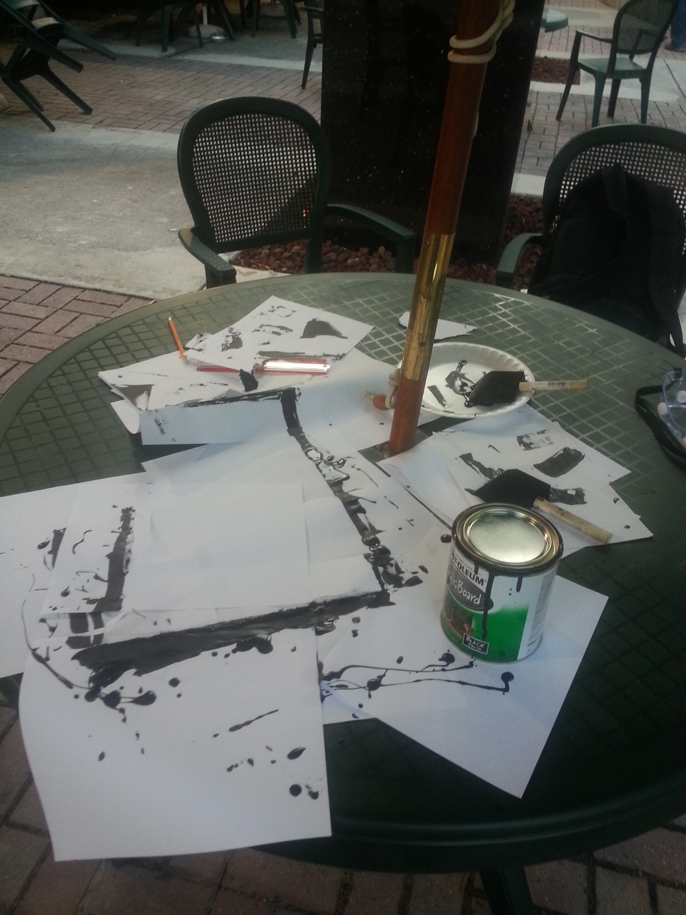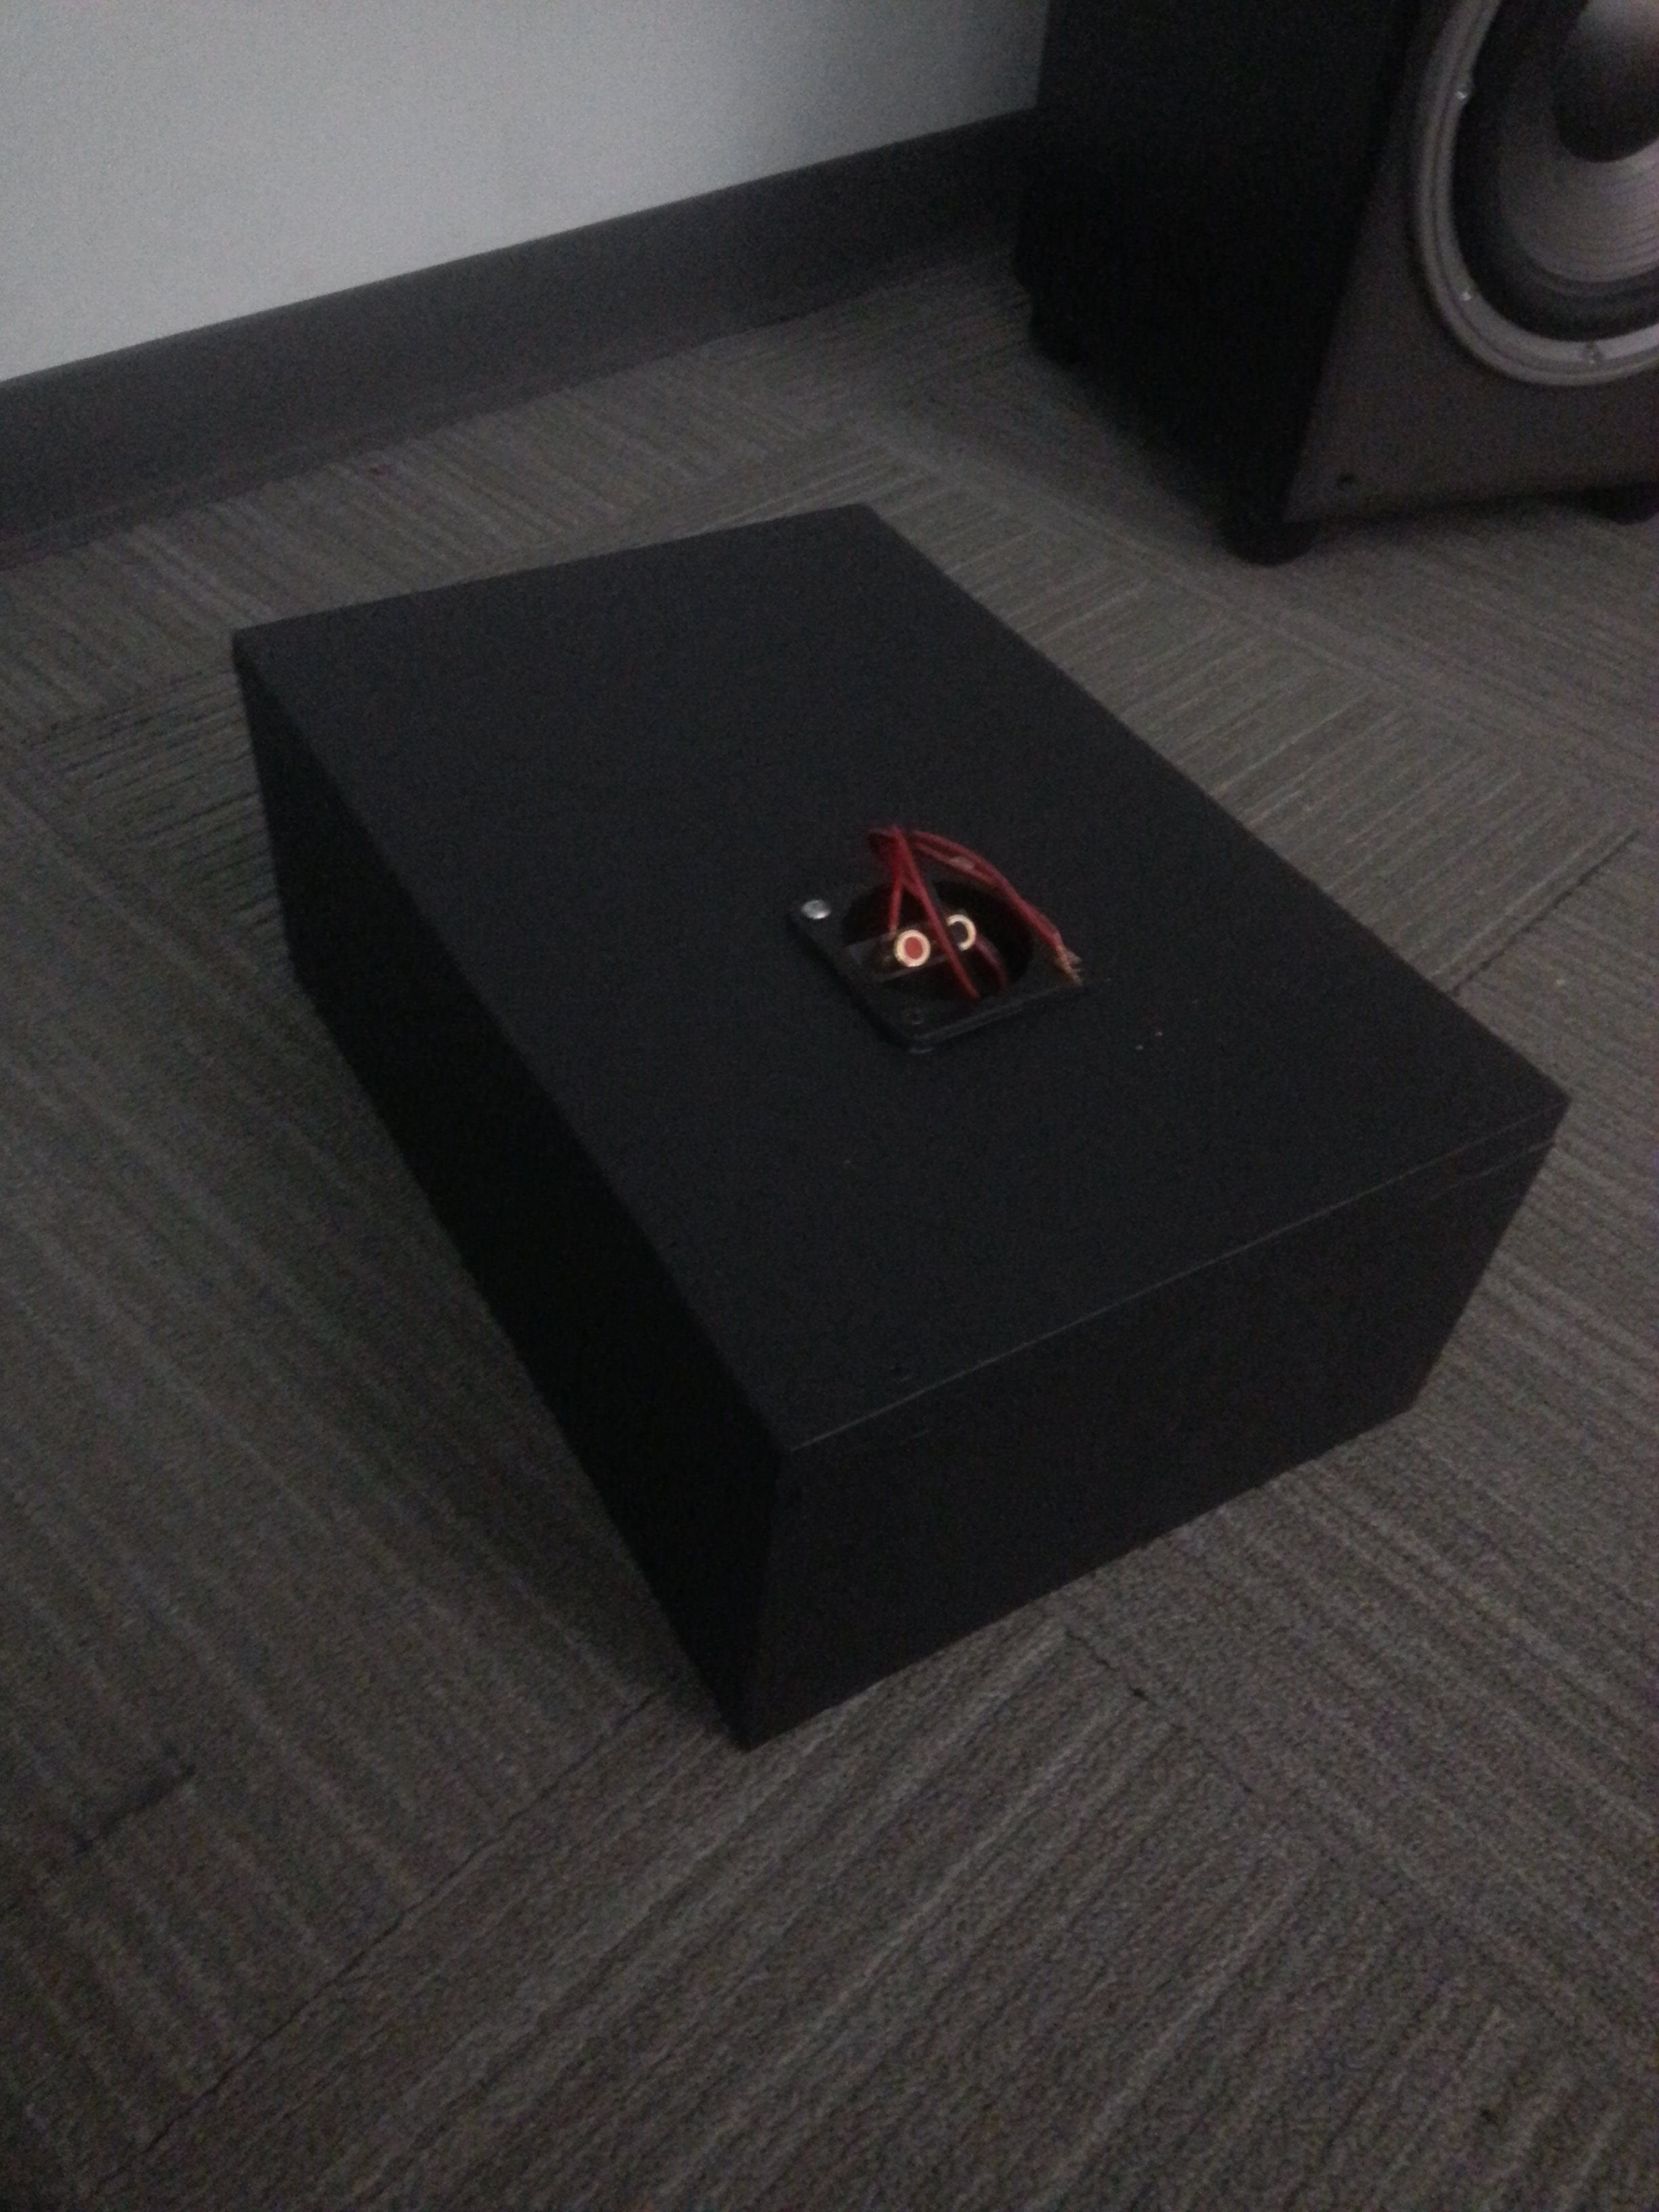Painting the enclosure
2. 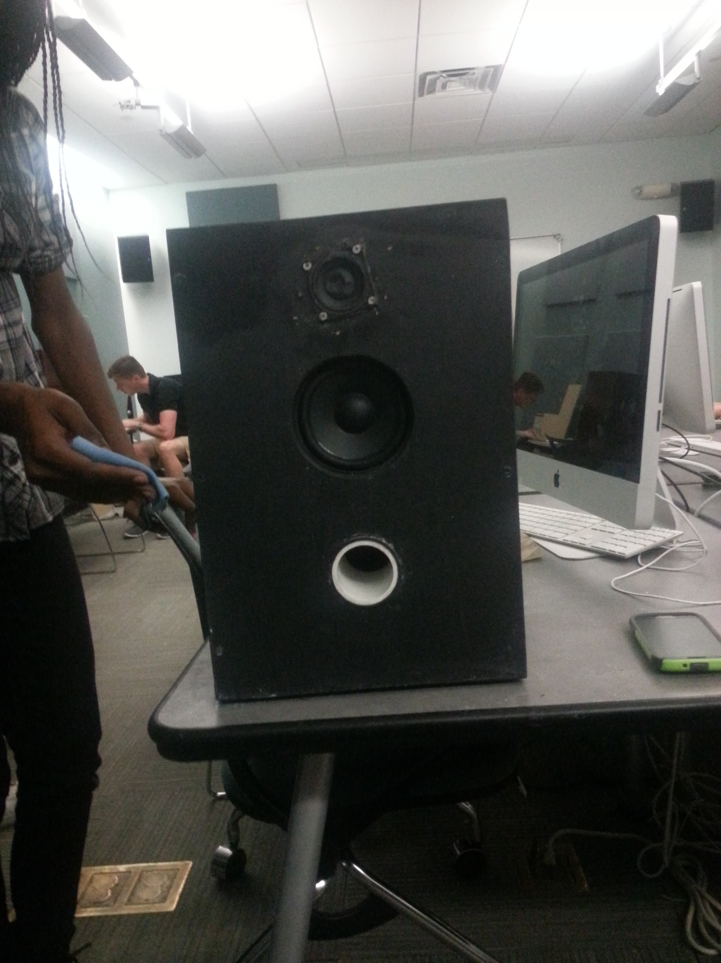Final Speaker